**AM1901i16 1.9meter Inkjet printer with 1 i1600 Printhead (the economic version)**

**$2400- $3400**

**Product Details**

Model Name:AM1901i16

Print Width: 1.9meters

Maximum Media width: 1.9meter

Print head： Epson i1600 print head

Number of Print head：1 piece

Resolution: 1440 dpi

Printing Speed: 4Pass Mode 12 square meters per Hour

Printing Media: PP Paper, Photo Paper, Vinyl, Transfer Paper,Blue back paper etc

Color : CMYK

Ink :Eco-Solvent ink,Sublimation Ink(or other water based ink)

Ink Capacity : 1 Liter per Color

Port of Connection to Computer : USB/NET

Print head to Media distance: 2mm to 3 mm

Printing Location system: Raster and Servo system

Ink drying System: Fan and heater

Motor and Driver system: Combined high precision motor and driver for Carriage and Step

Printing System: Sengyang

Ink Station: Aluminum high precision Print head Maintenance Station.

Rip Software : Maintop, RIIN, Photoprint

Photo format: JPG,TIFF,BMP,PDF

Heating system: Automatic Temperature Control system equipment.

Media supply system: Automatic Media roll-up system

Maximum Media weight: 90kgs

Power demand: 50/60HZ 220V AC

Working Temperature: 20-25 CESUS

Working Humidity: 40-70%

Machine Size: L2,980mm X W750mm X H1250mm

Net Weight:210 KGS

Packing Size: L2,900mm X W600mm X H400mm

Gross Weight: 250 KGS

(The real machine might be a little different to the printer showed in this catalog,especially some detail might be different)

Ink supply system

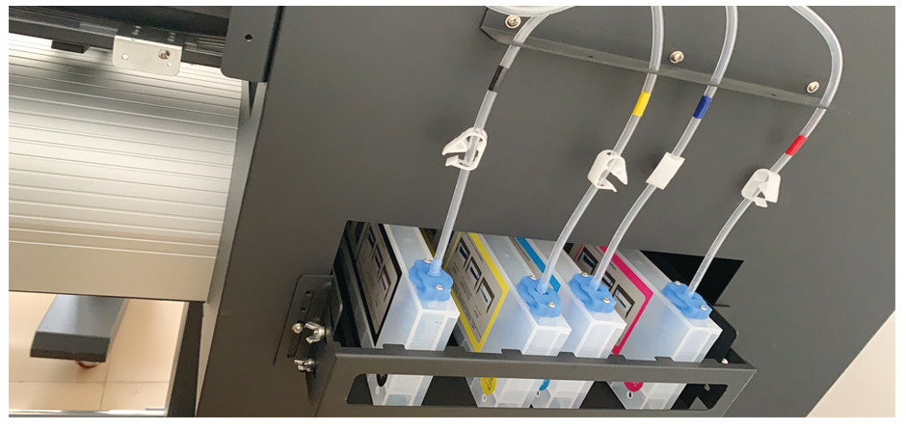

Print head Maintenance Station(Print Head cleaning station)

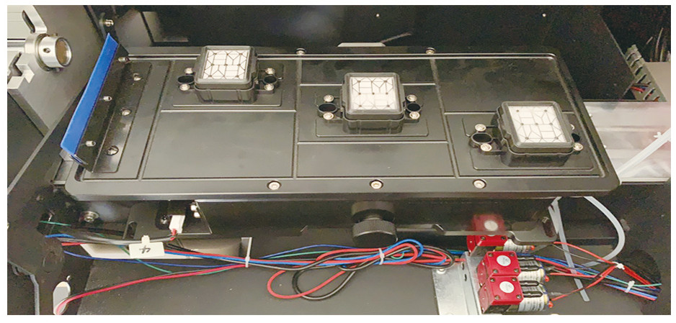

Media Pinch Roller

